GIU Food Truck Order System

Software Requirements Specification (SRS)

- Introduction:
1.1 Purpose:
The GIU Food-truck System is a comprehensive web-based application designed to enable the members of the GIU community to reserve menu items from specific food-trucks on campus for pick-up within a given time window, thus alleviating the problem with long-waiting times for food and beverage items during peak periods in between classes. This system enables seamless menu browsing, order placement, and order management for food-truck customers as well as providing a similarly intuitive, efficient, and scalable solution for food service providers.

1.2 Intended Audience:
- GIU students and staff
- Food-truck owners
- Project stakeholders

1.3 Scope:
This Software Requirements Specification (SRS) defines the requirements for the GIU Food-Truck System web application. The system includes functionalities for both customers and food truck vendors, covering areas such as user interaction, menu browsing, order placement, order management, and basic administrative controls.
The current scope does not include online payment processing, external user authentication, or integration with third-party systems. These features may be considered for future versions of the application.

1.4 Overview:
The document outlines the product vision, high-level architecture, functional requirements, non-functional requirements, interface requirements, constraints, and future scope.

- Product Vision and Scope:
2.1 vision:
To create a seamless and convenient online platform that connects university students and staff with on-campus food trucks, transforming the way they order and pick up food through an efficient, time-saving, and enjoyable experience.
2.2 scope:
Customers will be able to create accounts, log in, explore food truck menus, add items to their cart, and set preferred pickup times. Shops will have access to tools for managing their menus, viewing new orders, and updating order statuses as they progress. Additionally, the system will deliver real-time updates and notifications to keep both customers and vendors informed throughout the ordering process.
The initial version of the system will focus on these essential ordering and management features. It will not include online payment processing, third-party authentication or credit card integration, or delivery functionality. All orders will be limited to pick up only, with these excluded features planned for possible inclusion in future releases.
- High Level Architecture:
- Frontend: Modern HTML, CSS, JavaScript, and JQuery. Or JavaScript Framework
- Backend: RESTful API using Node.js
- Database: Relational (PostgreSQL)
- Authentication: currently, none
- Payment Gateway: currently, none
- Hosting: currently, none

- Functional requirements:
4.1 User stories:
1- Food truck patron:
- As customer, I want to create an account and log in so that I can securely access the food ordering system.
- As a customer, I want to browse menus from different food trucks so that I can choose what I want to order.
- As a customer, I want to add multiple items to my cart so that I can place a complete order at once.
- As a customer, I want to schedule a pickup time so that I can collect my order conveniently.
- As a customer, I want to receive notifications and real-time updates so that I know when my order is ready.
2- Food truck operators:
- As a vendor, I want to log in to my shop account so that I can access my dashboard.
- As a vendor, I want to add and update menu items so that customers always see accurate information.
- As a vendor, I want to receive and manage incoming orders so that I can prepare them efficiently.
- As a vendor, I want to change the order status so that customers stay informed.

4.2 Use case diagram:
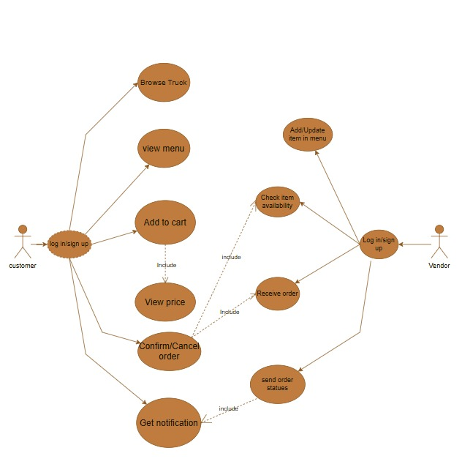

- Nonfunctional requirements:
- Response Time: Page load times under three seconds
- Concurrent Users: Support for at least 500 simultaneous users
- API Security: Rate limiting and input validation
- Backup & Recovery: Automated daily backups with disaster recovery plan
- System Operating Hours for Food Service Providers: From 8:00 AM to 5:15 PM
- System Operating Hours for Food-truck Patrons: From 8:15 AM to 4:45 PM

- Interface requirements:
Currently, there are no external interface requirements, as the system operates independently without access to outside authentication or payment services.
User and vendor verification are handled internally within the system.
Internal Interface:
A RESTful API will manage communication between the frontend and backend components of the system.
Possible future extensions may include integration with university authentication systems, online payment gateways, or third-party analytics tools, but these are beyond the scope of the current project.

- Constraints:
- Only university staff and students can register and place orders as customers.

- Only approved food truck operators can register and manage their menus as vendors.

- Orders can only be placed during the official operating hours of the food trucks.

- The system does not allow online payments; all payments must be made in person.

- The system does not support delivery; customers must collect their orders directly from the food truck.

- Future scope of the project :

- The system may include delivery options in future versions.

- Online payment features may be added for easier transactions.

- Future upgrades may support at least 1,000 simultaneous users instead of 500.

- Response time may be improved so that page load times are under two seconds.

- The system may include a rating and review feature for food trucks.

- Food truck operators may get access to detailed sales and performance report.

